Prevalence of Harm to Children
This analysis presents what we can know about harm to children and young people in New Zealand through a data driven lens. A true picture of the current level of harm to children in New Zealand is unknown.
The indicators here start to provide a picture of how safe children in New Zealand are, and how this is tracking over time. The indicators of wellbeing related to education (ECE); health (vaccinations) and feeling safe in the neighbourhood highlight the importance of collective agency work to make a difference for the longer term wellbeing of children. We expect that the planned work to implement the Oranga Tamariki Action Plan will build a deeper understanding of the underlying factors at play, with a view to identifying what further can be done to promote wellbeing. In particular, in-depth assessments will help to better surface unmet needs of the priority cohorts in each of the sectors of health, housing and education.
Number of victims reporting to NZ Police (age 0 - 19)
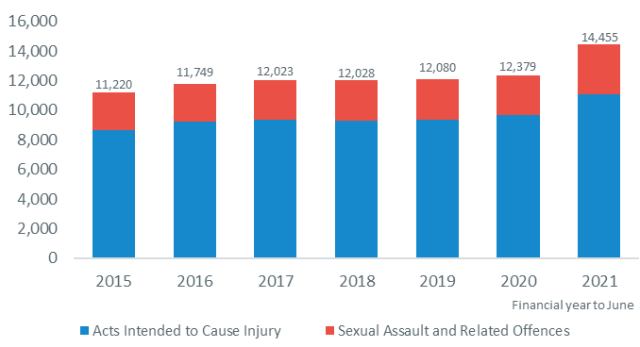
Source: Unique Victims (demographics) - Police Data NZ
Note: This data is records of victims who are reported to or discovered by Police, and recorded in Police systems.
Reported acts intended to cause injury increased 14% for young people aged 0-19 in the year ended June 2021. Reported sexual assaults and related offences increased by 25% during the same period to 3,376. The New Zealand Crime and Victim Survey (NZCVS 2018/19/20) estimated 27% of violent interpersonal offences were reported to Police, and only 8% of sexual offences were reported.
Count of injury mortality, by primary cause (age 0 - 19)
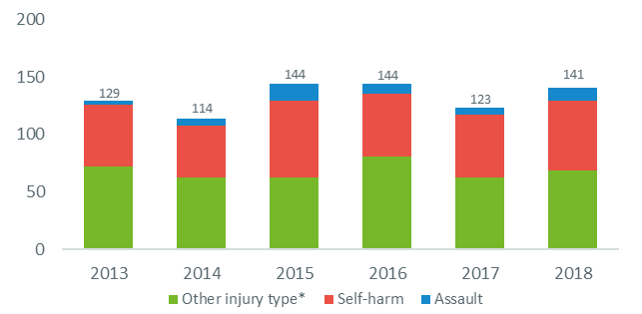
Source: StatsNZ Serious injury outcome indicators. UNICEF - New Report Card shows that New Zealand is failing its children
* Other injuries include accidental (falls, motor vehicle accidents, drowning, and work related injuries) or cause unknown
The number and rate of injury mortality for young people aged 0-19 has been slightly decreasing since 2015. Self-harm is the cause of over one third of injury mortalities for those aged 15-19. UNICEF stated that New Zealand’s youth suicide rate is the second-worst in the OECD with 14.9 deaths per 100,000.
Number of children and young people with a Substantiated Abuse Finding (age 0 - 17)
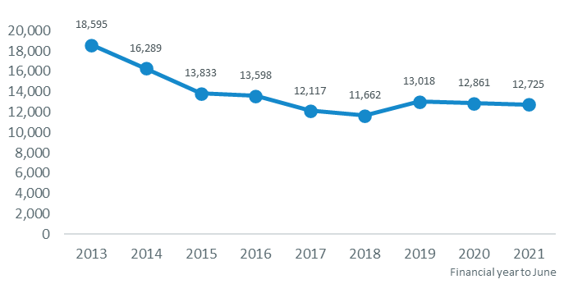
Source: Oranga Tamariki
Note: Graph shows distinct children and young people, who are counted once in the year. Children may have had more than one type of finding as a result of an assessment or investigation, or they may have had more than one assessment or investigation within a year.
The number of children and young people with a substantiated abuse finding have been decreasing since 2013, and remained stable in the last two years. COVID-19 lockdowns affected the number of harm notifications to Oranga Tamariki - reports from education and health providers dropped in this time in line with a decrease in interaction with these groups.
Potentially Avoidable Hospitalisations⁺ in the last year (age 0 - 17)
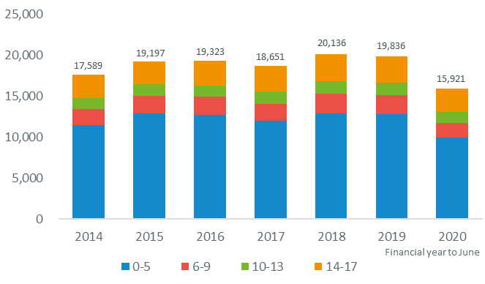
Source: Ministry of Health - National Minimum Dataset
Note: Potentially avoidable hospitalisations include respiratory conditions (including asthma, pneumonia, bronchiolitis, bronchiectasis), gastroenteritis, skin infections, and vaccine preventable illnesses. It also includes unintentional injuries and hospitalisations due to assault or self-harm.
The number of potentially avoidable hospitalisations have been relatively stable over time until a decrease in the year ending June 2020, where there was a significant decrease in hospitalisations. The COVID-19 Alert Level restrictions implemented at the end of March 2020 may have caused the drop in hospitalisations where people were hesitant to enter medical settings during the pandemic.
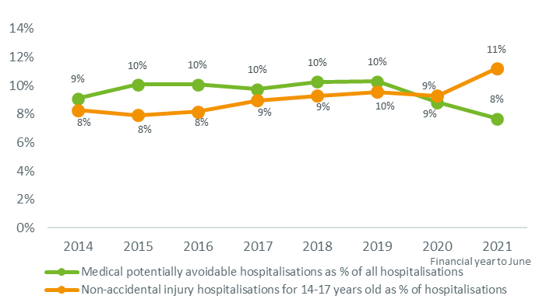
Note: 2021 datapoints are based on half a year of data
The proportion of medical potentially avoidable hospitalisations (of all hospitalisations) has decreased since the year ending June 2019. Most medical potentially avoidable hospitalisations are for those aged 0-5. There was a sharp increase in percentage of hospitalisations for 14-17 years olds that were for non-accidental injuries (assault and self-harm) between F2020 and F2021.
Number of children and young people with a NZ Police investigation for family harm⁺ (age 0 - 17)
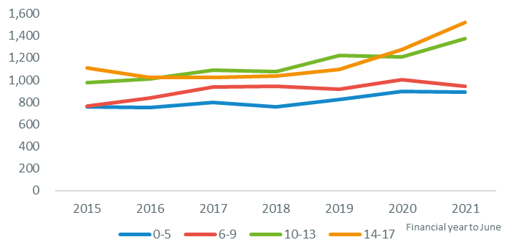
Source: New Zealand Police Recorded Crime Offenders and Recorded Crime Victims Data+
Note: Counts are for where child or young person is recorded in a family harm investigation. There can be multiple people per incident of family harm and there can be multiple unique incidences per person.
Police investigations for family harm include interpersonal offences where the relationship to the victim is a family member; where the offence code is assault on child; or where the offence code is domestic assault.
The number of children and young people with police investigations for Family Harm has been increasing over time from 3,609 in F2015 to 4,734 in F2021. Investigations have increased significantly in the last two years for families with children aged 14-17.
Note in early 2021 changes were made to the Police phone app to improve the way that Police record family harm offences. Previously the default setting on the app was ‘5F’ (family harm call out with no offence). This default setting was removed in early 2021.
+ These are not official statistics. They have been created for research purposes from the Integrated Data Infrastructure (IDI) which is carefully managed by Stats NZ. For more information about the please visit https://www.stats.govt.nz/integrated-data.

Protective Factors
The below presents a range of protective factors that indicate good wellbeing for children and young people.
Proportion of 0 - 4 year olds attending Early Childhood Education
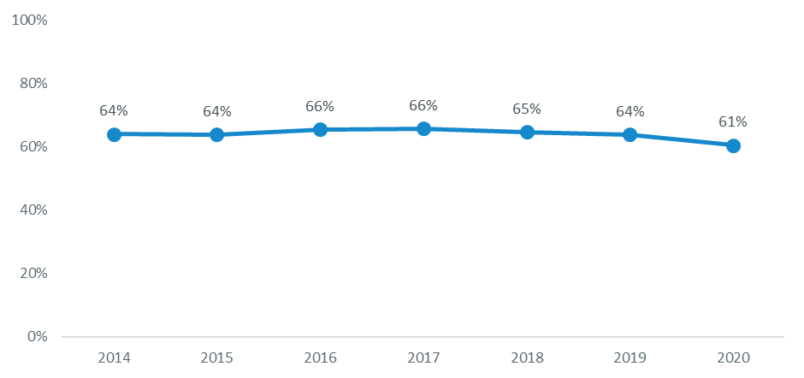
Source: Ministry of Education.
Note: In 2014 data changed from collecting enrolments in ECE to participation, and should not be compared.
There has been a drop in the proportion of children attending Early Childhood Education in the last four years. The sector has stated this could be because of COVID-19, teachers and service providers despondency in a 2018 survey, and an increase of ECE services placed on official notice or had licences withdrawn for not meeting regulatory standards.
Percent without cavities (dental caries), by age group
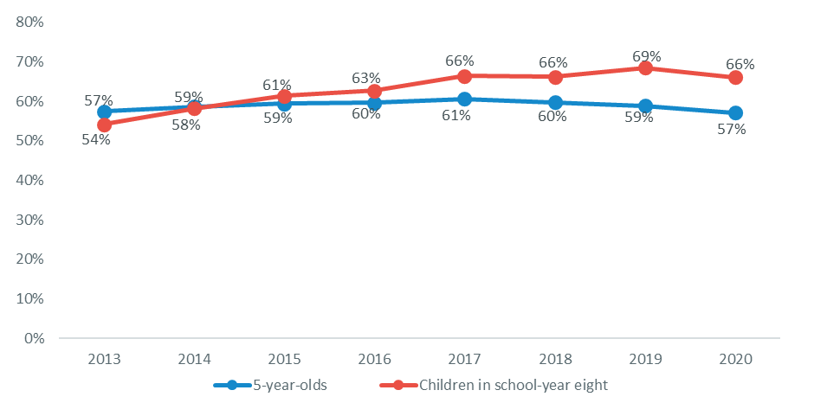
Source: Ministry of Health and Community Oral Health Service.
The proportion of children in school-year eight without cavities increased between 2013 and 2019, with 69% of children in school year-eight without cavities in 2019 - and then decreased between 2019 and 2020 to 66% without cavities. The proportion of five year-olds without cavities has remained relatively stable over time.
Childhood Immunisation Coverage - percent fully immunised
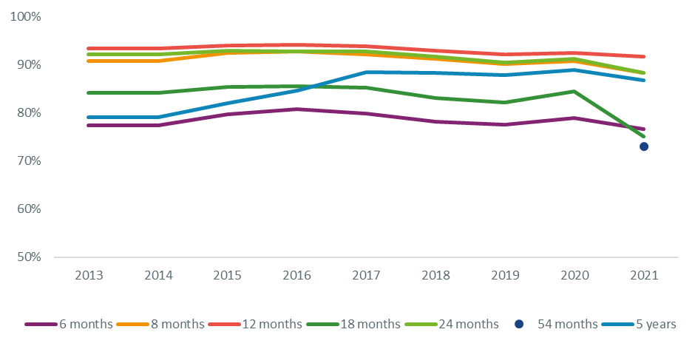
Source: Ministry of Health - National and DHB immunisation data
Note: There was a timeseries change in 2020 when the vaccine schedule was amended, this is expected to correct over time.
There was a slight decrease in the proportion vaccinating at 6, 8 and 24 months as well as five years in 2021. This was due to uncertainty by parents whether regular vaccinations were occurring during COVID-19 lockdowns. The significant decrease of 18 months vaccinations are due to a change in the schedule and should correct over time.
Other protective factors
Many indicators of wellbeing are not collected regularly enough for timeseries yet. However here are some findings that support the Child and Youth Wellbeing Strategy.
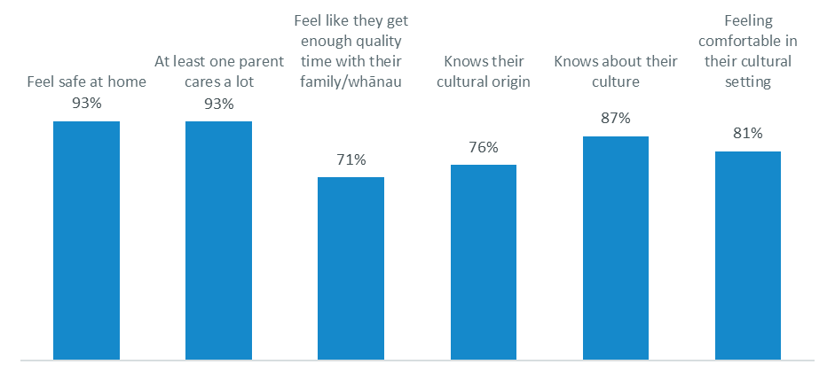
Source: Youth19 Rangatahi Smart Survey.
Note: This survey population is Northland, Auckland, and Waikato secondary schools.
Outcomes and indicators for wellbeing have been developed in the Child and Youth Wellbeing Strategy. Outcomes include "loved, safe, and nurtured," "accepted, respected, and connected." The Youth19 Survey has indicators on these outcomes, and found most young people reported feeling safe at home, feel safe at school all or most of the time, and have at least one parent who cares a lot.

